**Big Mountain Resort**

**Problem Statement:**

With incredible views of Flathead National Forest and Glacier National Park**, Big Mountain Ski Resort** is situated in Montana. 11 lifts, 2 T-bars, and 1 magic carpet with a 3.3-mile longest stretch serve the resort. Skiers and riders of all levels and abilities can access the longest run as well as beginner slopes. The objective here is to generate a profit during the upcoming skiing season by correctly pricing tickets to cover the additional running expenses of 1,540,000 resulting from the additional chair lift installation.

**Initial Data Wrangling:**

There were 330 resorts listed in the initial raw data from various states. As a first step, all columns in this state are checked for null values, and those that contain them are removed. After carefully examining this data throughout the states, we discovered that some of the states and regions weren't valid. The incorrect state information and the resort with the fewest data are removed from the data. Once the data had been cleaned up, we began looking for a relationship between ticket prices and other resort amenities. As a first step, a box plot is used to show the average cost of resort tickets, which also assisted in removing outliers. Two ticket prices were present in the raw data: a weekend price and a weekday price (Fig 1).

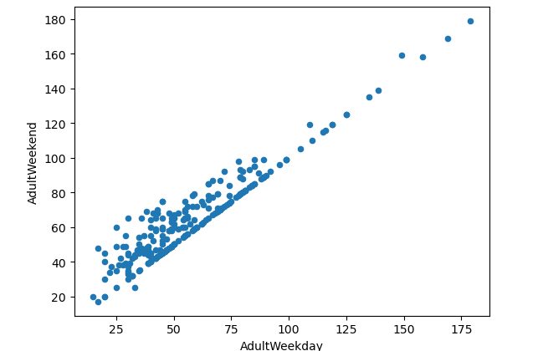Fig 1: clear line where weekend and weekday prices are equal. Weekend prices being higher than weekday prices seem restricted to sub $100 resorts.

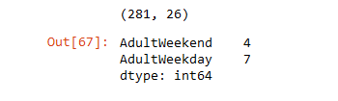

Weekend and Weekday prices were almost similar with Weekend prices have the least missing values of the two. Weekend ticket prices are used in future study as weekday prices were almost similar to other.

**Data Analysis:**

The resort density is measured during the data analysis phase to determine the ratio of resorts serving a particular population or a certain area after state-wide market data has been analyzed. In terms of resorts per 100,000 people, Montana, the state we are interested in, ranks fourth. When the number of runs and fast quads are balanced, it has been seen that ticket prices are increasing. We used the PCA technique to locate the linear combinations of the original characteristics that are uncorrelated with one another and to order them by variance to better comprehend the correlations between different features. The association between the features is visualized using a heat map of ski_data, which shows that the summit and base elevations are highly correlated and that the ticket price has a fair correlation with features like fastQuads, Runs, total_chairs, Snow Making per acres, and Vertical drops.

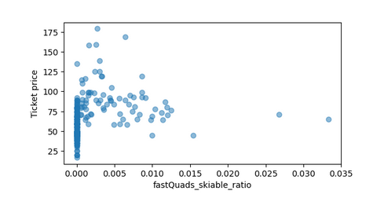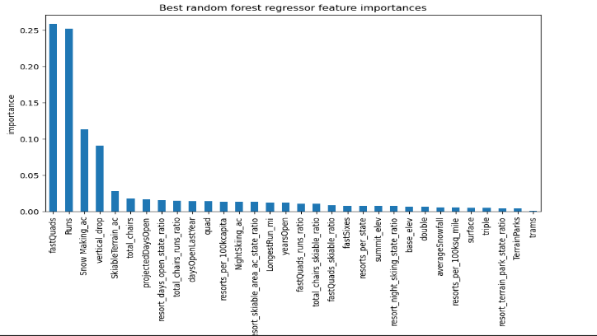Additional data analysis using scatter plots between different parameters revealed that the cost of admission falls as the number of quads per skiable area increases (fig 2). For the best possible ticket price, runs and fast squads must be carefully balanced throughout the resort. The random forest model and the linear regression model were applied for further data analysis and price prediction. The Random Forest Model seems to perform best when cross-validating data. Big Mountain resort tickets were less expensive, according to the models' findings, and the price may go up. According to the Random Forest Model (fig 3), the features FastQuads, Runs, Snow Making Ac, and Vertical Drop have the biggest Impact on Ticket Prices. The heat map graph and predict model both showed the same feature association, further validating the findings.

Fig: 2 Fig: 3

Big Mountain resort stands out in terms of total_chairs, FastQuads, Runs, and LongestRun_Mi skiable terrain according to further model study. A model was used to forecast the outcomes of each of the four enhancements that the business had suggested. Features like vertical_drop, assured snow, and total chairs justify the rise in ticket price, which will bring in $347,4638 more revenue. Big Mountain Resort had already made a $1540,000 investment in additional chairs, but the model anticipated a $0.29 increase in ticket price for this amenity. To ascertain which feature enhancement combinations support ticket price rises the most, various feature combinations are examined in the predict model. It has been demonstrated that increasing the seating capacity and the vertical drop allow for a $1.99 ticket price increase, which has the potential to bring in $3473638. Because more chair lifts have been already added, the second option, which would increase the vertical drop, seems to be more promising.

**Conclusion:**

Resort ticket price is underpriced. With new chairs addition, operating cost is increased by $1540000. As per the predicting model, increasing vertical drop as well as additional chair lifts supports ticket price increase. Although the additional chair operating costs are known, the final operating costs also need to account for the additional vertical drop operating costs. This model must be made available for business users to use in order for them to test it further and modify the pricing.